CIS 235 PROJECT MILESTONE (1): Project Proposal & ER-Diagram

Project Group Number (in Blackboard): Group (4)
Section Number: 4MA1
Project Title: super market
Leader | ID | Member Name
* | 2240002889 | Mustafa Abbas Abokhadher
 | 2240007709 | Abdulmuhsen Mohammed Qasem
 | 2240005893 | MOHAMMED NASSER ALMARHOON
 | 2240003775 | mahdi nasser alzaid
 | 2240004292 | Ammar Nasser AL MATTER
 | 2240002437 | fadhel abbas al asaad

Instructor Name: Dr. Zakariya Alhassan
Date of Submission:
Obtained Marks: /5

Project Proposal (1 Mark)
Description:
☑ The supermarket operates through multiple branches, each with a unique number, name, and specific location. Each branch is managed by an employee, and we keep track of when they started managing the branch.
☑ Each branch works with different suppliers to stock its products. A supplier has a unique number and a company name and can supply products to multiple branches. We maintain records of these supplier-branch relationships.
☑ The supermarket offers a variety of products, each identified by a unique barcode and name. Products are distributed across different branches, and we keep track of which products are available in each branch.
☑ Employee details are stored in the database, including first name, middle name, last name, Social Security number, address, gender, and birth date. Employees are assigned to a branch but may work in multiple locations. We also track the number of hours they work in each branch, along with their direct supervisor.
This database is designed to streamline supermarket management by organizing employee records, branch details, supplier relationships, product distribution.

Entities:
Employees, Products, Branches, Suppliers, Transaction

Systems Users (Actors):
 | User Role | Privileges
1 | Manager | Access to employee records, scheduling, and performance metrics
2 | Auditor | May have access to review all transaction data but not modify it
3 | Branch Manager | Access to branch performance reports, employee schedules,.
4 | Stock Controller | Ability to add, update, or remove products from the inventory.
5 | Procurement Manager | Ability to approve new supplier requests and manage existing supplier information

ER-Diagram (4 Marks)
System Requirements & Relationship Between Entities:

Branch
Each Branch has a number, name, and one or more locations. A Branch is managed by an Employee, and the system tracks the start date of the manager.

Employee
Each Employee has SSN, Address, Gender, and a Name (first, middle, last). Employees have work hours and a direct Supervisor.

Supplier
Each Supplier has a number (ID) and name (company name). A Supplier supplies products to multiple Branches.

Product
Each Product has a unique barcode and name. Products are distributed to multiple Branches.

Entity Relationships

Branch ↔ Employee ("works for")
Employee works for a Branch. An Employee manages a Branch, tracked with a start date.

Branch ↔ Supplier ("deal with")
A Branch has a deal with one or more Suppliers for products or services.

Branch ↔ Product ("distribution")
Products are distributed to Branches.

Employee ↔ Supervisor
Each Employee reports to one Supervisor, another Employee in the same Branch.

Employee ↔ Work Hours
Employee tracks their work hours for tasks.

ER Diagram:

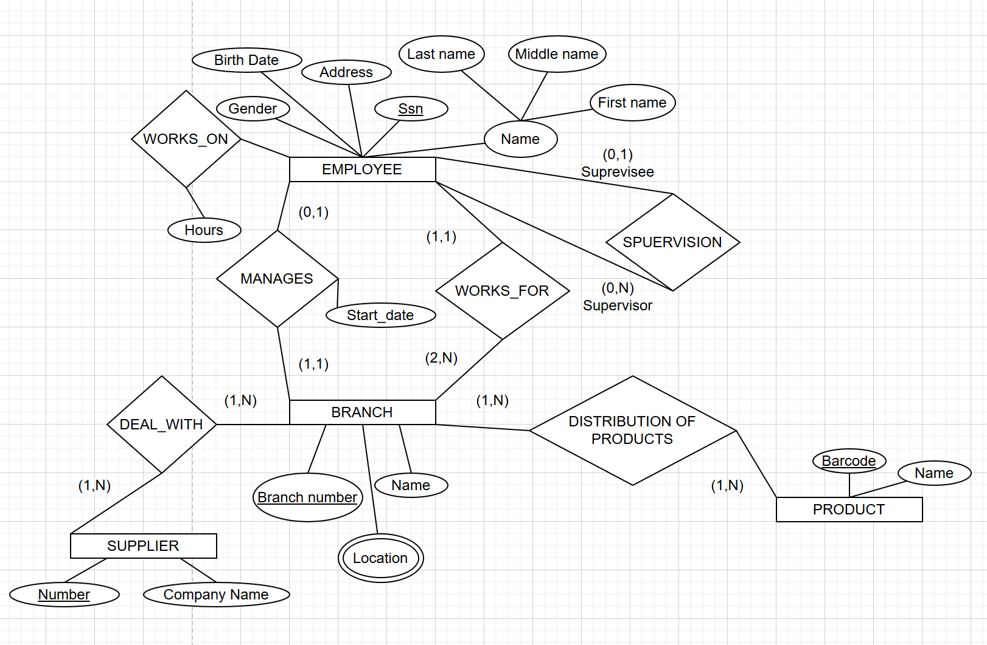

Instructor(s) Approval: Approved Not Approved (needs to be changed)
Feedback Comments:

